Name:________________________ Date:_____________

Directions: You may use a scientific calculator to complete this test. Put a box around your answers. Show all work for credit.

1. Use the Intermediate Value Theorem to show the there is a zero between 3 and 4 for the function . Explain yourself.
2. Given the function find function f(-2) using the Remainder Theorem and through direct computation.
3. Is  a factor of ? Why or why not?
4. List all possible rational roots for .
5. Find all actual roots for.
6. How many of the roots in #5 were positive real numbers? How many were negative real numbers?
7. Write a polynomial function (with real coefficients) of least degree with leading coefficient 1 and the zeros being 1+2i, 3, and -4(multiplicity 3). DO NOT FULLY MULTIPLY OUT YOUR ANSWER!
8. Use synthetic division with the function  to determine if 1 is an upper bound. Explain.
9. Find the intervals where the function  is positive and negative. Sketch a graph of the polynomial.
10. Find the domain and intercepts for .
11. For , what is happening to f(x) as ? 

For #12 & 13, find all asymptotes (horizontal, oblique, and vertical) and holes for the following functions:

1. 
2. 
3. Draw a rational function with a hole at x=-2, a VA at x=1, and a HA at y=2.

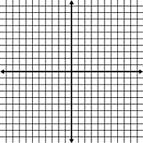

1. Draw a graph whose

* Domain: all real numbers except -1 and 4.



* x-int: (-3,0),(5,0)
* y-int: (0,6)
* VA: x=-1
* 
* 
* Hole at (4,1)
* HA: y=2
* Positive:
* Negative: 
* Range:

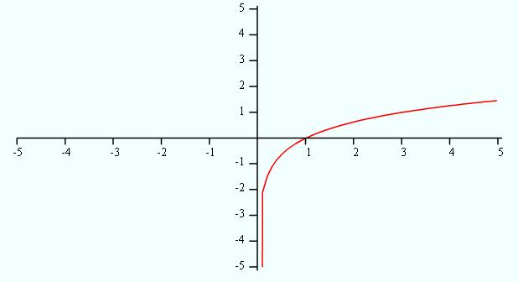

Given the logarithmic function, 

17.

1. Graph .
2. Graph .
3. Evaluate
4. Combine into a single logarithm: 
5. Separatein terms of logarithms of x, y, and z.

Find the exact answer for:

1. 
2. 